What can you measure with MST?
MicroScale Thermophoresis is an easy, fast and precise way to quantify biomolecular interactions. It measures the motion of molecules along microscopic temperature gradients and detects changes in their hydration shell, charge or size.
When performing a MST experiment, a microscopic temperature gradient is induced by an infrared laser, and the directed movement of molecules is detected and quantified using either covalently attached dyes, fluorescent fusion proteins, or intrinsic fluorescence.
MST is performed in thin glass capillaries in free solution thus providing close-to-native conditions (immobilization free in any buffer, even in complex bioliquids) and a maintenance free instrument.
Besides binding affinities (K_{d}) also dimerization or multiple component interactions can be measured.

MST Applications:
Interactions between any kind of (bio-) molecules, from single ions (40 Da) or small molecules (300 Da) up to ribosomes (2.5 MDa, up to 100 nm).
- Protein-Protein/Peptide
- Protein-Nucleic Acid
- Protein-Small Molecules
- and many more!

Get your dissociation constant in any buffer in 10 Minutes:
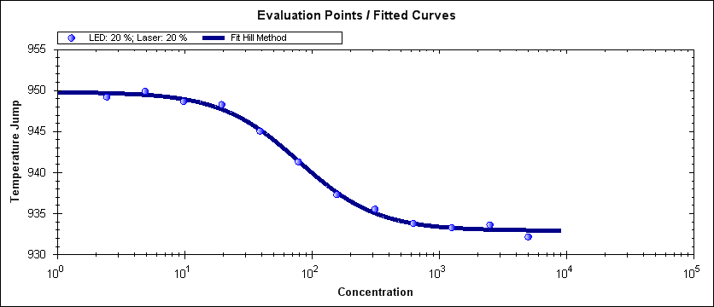
Watch our Handling Movie and see how it works:
http://www.nanotemper-technologies.com/products/monolith-series/monolith-nt115-series/handling-nt115-series/

Sample volumes needed for measurement:
- 50-100 µl of the protein to be labeled with a concentration of 2-20 µM
OR
- 250 µl of the protein with intrinsic fluorescence with a concentration of 200 nM – 1 µM
AND
- At least 50 µl of the unlabeled interaction partner with a concentration at least 20 x higher than the expected K_{d}
- 50 ml interaction buffer (no limitations regarding buffer composition)
V001_2015-01-15

